Quarterly Report – Public Page

Date of Report: 4th Quarterly Report, September 27, 2024
Contract Number: 693JK32310010POTA
Prepared for: Government Agency: DOT and Co-funders
Project Title: Standardize the Application of Vapor Corrosion Inhibitors
Prepared by: Pipeline Research Council International (PRCI), Inc.
Contact Information: Janie Norton, jnorton@prci.org 703-205-1600 ext: 105
For quarterly period ending: September 30, 2024

1: Items Completed During this Quarterly Period:

Item # | Task # | Activity/Deliverable | Title | Federal Cost | Cost Share
2 | 1 | Conduct literature review of the VCI qualification and related testing methods | Summary of the literature review to be included in the first quarterly report | $10,424 | $2,606
4 | 2 | Development of the test matrix for VCI qualification tests | Summary of the test matrix to be included in the quarterly report | $12,000 | $3,000
8 | 3 | Develop plans for the VCI effect experiments | Summary of the VCI effect experiment plan to be included in the quarterly report | $3,127 | $782
6 | 3 | Initiate Control Tests | Summary of the control tests started in the second quarter to be included in the quarterly report | $16,000 | $4,000
9 | 3 | Analyze the monitoring data from the VCI control tests | Results to be included in the quarterly report | $3,127 | $782
13 | 5 | 4th quarterly status report & project management | Submit 4th quarterly report | $6,406 | $1,602

2: Items Not Completed During this Quarterly Period:

Item # | Task # | Activity/Deliverable | Title | Federal Cost | Cost Share
11 | 3 | Initiate VCI effect experiments | Summary of the VCI effect experiments initiated to be included in the quarterly report | $20,848 | $5,212
12 | 3 | Develop plans for the VCI migration experiments | Summary of the VCI migration test plan to be included in the quarterly report | $3,127 | $782

3: Project Financial Tracking During this Quarterly Period:

Note that this chart reflects Federal share only:

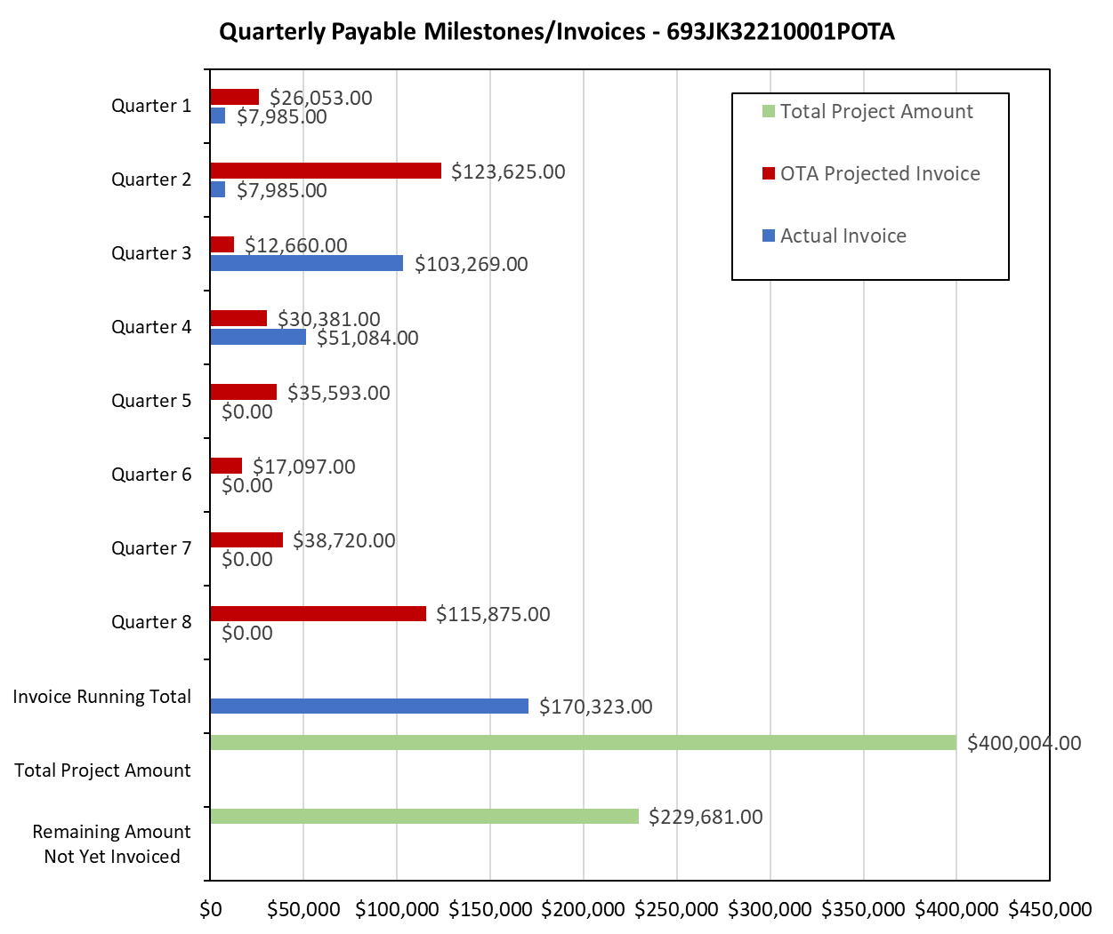

4: Project Technical Status –

Item 2, Task 1 ⎯ Conduct literature review of the VCI qualification and related testing methods. Summary of the literature review to be included in the first quarterly report: The following documents were reviewed: NACE TM0208, German Test Method TL 8135-002, AMPP C2023-19169 conference paper, ASTM D5534 Test Method, and PRCI reports on VCIs. Both NACE TM0208 and TL 8135-02 are designed to evaluate VCIs’ ability to inhibit corrosion in vapor phase for the ferrous materials. AMPP C2024-20747 provides additional suggestions on using carbon steel grade that could be more economical and consistent while using NACE TM0208 and TL 8135-002. ASTM D5534 is focused on automobile application. The PRCI report works (Shukla et al., 2018, 2022) are directly focused on evaluating VCIs for tank bottom application. In the PRCI studies, the following parameters were controlled: temperature, sand moisture level (mostly set at 75% of the saturation), and coupon material was the carbon steel grade A36. The sand salt content was sometimes controlled, and not controlled, in the PRCI studies. The sand grain size distribution was not controlled. Regarding field application, VCIs are estimated to have been applied in 700-1000 tanks worldwide, with approximately 50/50 distribution between the two commercially available products. Most operators use VCIs to either supplement CP or when CP is suboptimal. This item links to item 2 in Attachment 1 Team Project Activities. This item links to item 2 in Attachment 2 Project Deliverables.

Item 4, Task 2 ⎯ Development of the test matrix for VCI qualification tests. Summary of the test matrix to be included in the quarterly report: The test matrix was developed based on the analysis of 255 sand samples and prior experience. One of the chloride concentrations of 10 ppm was selected based on API 651. The second chloride concentration was selected to be 30 ppm, based on the sand sample analysis. The third chloride value of 300 ppm was selected, also based on the sand sample analysis. The matrix for the VCI qualification tests is listed in Table 1. The test matrix parameters are being used as-is for the control tests. For the VCI effect experiments, the only two of the three chloride values will be used. Similarly, either 10 or 30 ppm chloride values will be used for the VCI migration experiments. This item has been completed. This item links to item 4 in Attachment 1 Team Project Activities. This item links to item 3 in Attachment 2 Project Deliverables.

Item 8, Task 3 ⎯ Develop plans for the VCI effect experiments. Summary of the VCI effect experiment plan to be included in the quarterly report: The test matrix for the VCI effect experiments is provided in Table 1, only two of the three chloride values will be used for the VCI effect experiments. These experiments will be started once sufficient ER probe data from the control experiments is available. The VCI effect experiments will be conducted at the lead lab and at two other locations, in consultation with the VCI vendors. It is estimated that the VCI effect experiments will be started during the 5th quarter. This item links to item 4 in Attachment 1 Team Project Activities. This item links to item 3 in Attachment 2 Project Deliverables.

Item 6, Task 3 ⎯ Initiate Control Tests. Summary of the control tests started in the second quarter to be included in the quarterly report: The control tests were started as per the text matrix in Table 1 in the 4th quarter. An image of various control tests is presented in Figure 1. A total of 36 experiments have been setup. Four quadruplicate experiments have been setup at each combination of salt and moisture contents; one of the four quadruplicate has ER probe for corrosion monitoring, and another one where coupons exposed surface is intermittently exposed to the sand electrolyte. This item links to item 5 in Attachment 1 Team Project Activities. This item links to item 5 in Attachment 2 Project Deliverables.

Item 9, Task 3 ⎯ Analyze the monitoring data from the VCI control tests. Results to be included in the quarterly report: The control tests were started at the beginning of the 4th quarter; electrical resistance (ER) probes are being used as monitoring tools. For each set of conditions, one ER probe is used in one of the quadruplicate tests. The corrosion rates for the 10 ppm Cl⁻ are the lowest and the corrosion rates are highest for the 300 ppm Cl⁻. The corrosion rates for the 30 ppm Cl⁻ are somewhat in-between the 10 and 300 ppm. This item links to item 7 in Attachment 1 Team Project Activities. This item links to item 6 in Attachment 2 Project Deliverables.

Item 13, Task 5 ⎯ 4th quarterly status report & project management. Submit 4th quarterly report: The fourth quarter meeting was held on September 4, 2024. This report satisfies this item. This item links to item 13 in Attachment 1 Team Project Activities. This item links to item 13 in Attachment 2 Project Deliverables.

5: Project Schedule –

Item 11, Task 3 ⎯ Initiate VCI effect experiments. Summary of the VCI effect experiments to be included in the quarterly report: Preparation is underway to start the VCI effect experiments and it expected that all the experiments will be started by early 5th quarter, i.e., next quarter. The revised plan is to finish this item by the next quarter.

Item 12, Task 3 ⎯ Develop plans for the VCI migration experiments. Summary of the VCI migration test plan to be included in the quarterly report: Additional control tests data is needed to develop plans for the VCI migration tests. As more monitoring data becomes available in the next quarter from the control experiments, a plan will be developed for setting up and conducting the migration experiments.

The project is behind schedule. The project team plans to catch up as much as possible in the next quarter.

